On Developmentally Appropriate Practice….And Why We Don’t Push Kids Down the Stairs – Amanda Morgan
OCTOBER 16, 2013 by NOTJUSTCUTE filed under: BUILDING READERS, CHILD DEVELOPMENT & DAP, LEARNING THROUGH PLAY AND EXPERIENCE 70 Comments
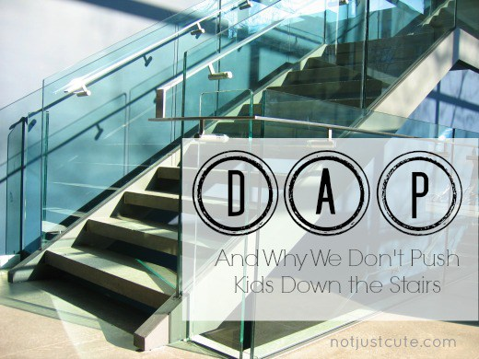
Toddlers can’t walk down the stairs with alternating steps. They just can’t. While your kindergartener bounds down the stairs taking each step in stride (or several in one super-hero bound, as mine is prone to do), your toddler will cling to the wall or rail as she takes a careful step down with one foot, then brings the other foot to that same step to stand firmly before venturing down in that same slow, tentative manner for another (step together), then another (step together), then another (step together).
It generally isn’t until at least their third year that young kids begin to master this foot-switching-feat. It’s a skill that certainly requires experience and practice, but it’s not something we can teach an 18 month-old, even if he’s an accomplished walker. We don’t force tiny toddlers down the stairs on alternating feet in an attempt to secure our child’s “early-alternating-foot-stair-climbing status”. It wouldn’t serve any purpose and the child would likely only get hurt.
Alternating steps on stairs is perhaps a more obscure skill, but it is considered a developmental milestone because it’s indicative not only of a motor skill that you can watch your child perform right before your eyes, but because it’s a manifestation of the brain development that we can’t see. Particularly necessary is the maturation of the cerebellum and corpus callosum as well as the myelination, or protein coating, of millions of tiny nerve fiber pathways that eventually all work together to make such coordination, balance, and truly sophisticated movements possible. This process takes time! Usually at least three years, and for some closer to four.
For some reason, we seem to be OK with this fact as a society and generally let kids build this skill as time, experience, and development do their magic.
We don’t worry much (or even talk much) about when our child mastered this skill or compare it against when our nieces, nephews, and neighbors mastered the same task.
We don’t clamor for videos and books that promise to get our kids alternating their feet sooner, to give them an head start for all the stair-climbing that lies ahead of them.
We don’t introduce new standards that require each group of toddlers to begin alternating their feet just a bit earlier than the cohort group ahead of them.
We don’t push them down the stairs.
So why do we do it with other skills?
Why do we give young children tasks, standards, and environments that are not appropriate to their developmental readiness? Why do we ignore the fact that the parts of their brains needed for these tasks are still under construction? Why do we impose timelines that turn a blind eye to developmental processes and a deaf ear to individual differences?
Why do we figuratively push kids down the stairs on other skill sets, possibly causing harm and certainly creating unnecessary frustration and anxiety?
Developmentally Appropriate Practice is always appropriate.
Policies and programs will not change the facts of human development.

